Track 3: Risk & Financial Analysis
Bank Loan Stress Test — Solution Set
Questions 1, 2, 3, 4, 5, 7, 8, 12
Dataset: Bank Loan & Credit Risk (Kaggle) — 45,000 records, 14 columns
Frameworks: P-values, 1NF–3NF Normalization, Relational Joins

Question 1 — Apply 2NF and 3NF to Separate Borrower from Loan Data

The problem with the raw flat file (1NF only)
The raw loan_data.csv is technically in 1NF (atomic values, no repeating groups), but it bundles three different concerns into every row: borrower demographics (age, gender, education, income), credit history (credit_score, credit history length, prior defaults), and loan transaction details (loan_amnt, loan_intent, loan_int_rate, loan_status). When a single borrower takes multiple loans, every demographic attribute is duplicated — creating redundancy, update anomalies, and risk to data integrity.

Normalization plan
Split the flat file into three tables, each with a single subject area:
Table | Grain (one row per…) | Key columns
borrowers | Unique borrower | borrower_id (PK), age, gender, education, income, employment, home ownership
credit_history | Borrower (1:1 with borrowers) | borrower_id (PK & FK), credit history length, credit_score, prior defaults flag
loans | Individual loan transaction | loan_id (PK), borrower_id (FK), loan amount, intent, rate, percent income, status

Why this satisfies 2NF and 3NF
- 2NF satisfied: Borrower attributes (age, gender, education, etc.) no longer live in the loans table — they only appear in the borrowers table where they fully depend on the primary key (borrower_id). They no longer repeat in every loan row.
- 3NF satisfied: Credit attributes depend on borrower_id, not on loan_id. By separating them into credit_history, we eliminate the transitive dependency loan_id → borrower_id → credit_score from the loans table. Credit data also has its own update cadence (monthly bureau refresh) distinct from demographics.

Schema diagram
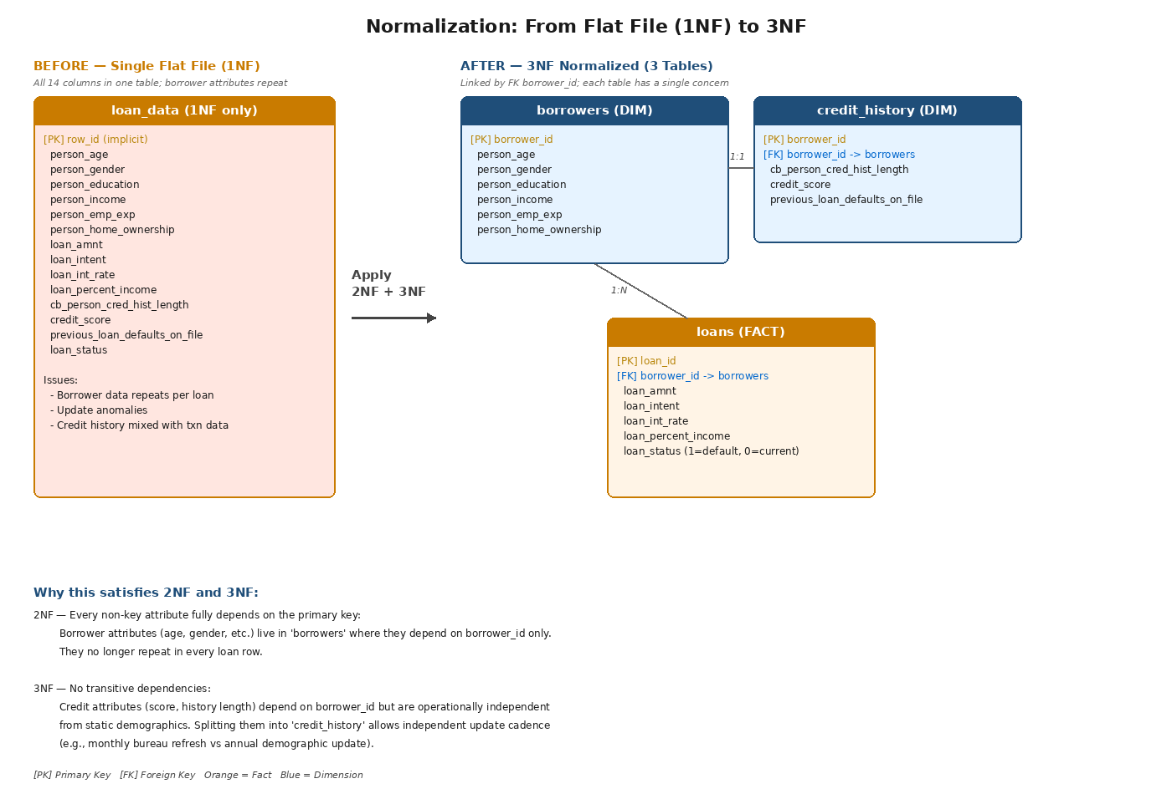
Figure 1 — Normalization from 1NF flat file to 3NF schema. Borrowers and credit_history have a 1:1 relationship; borrowers and loans have a 1:N relationship.

DDL for the normalized schema
SQL — DDL
CREATE TABLE borrowers (
borrower_id INT PRIMARY KEY,
person_age INT NOT NULL,
person_gender VARCHAR(10),
person_education VARCHAR(20),
person_income DECIMAL(12,2),
person_emp_exp INT,
person_home_ownership VARCHAR(15)
);

CREATE TABLE credit_history (
borrower_id INT PRIMARY KEY,
cb_person_cred_hist_length DECIMAL(4,1),
credit_score INT,
previous_loan_defaults_on_file VARCHAR(3),
FOREIGN KEY (borrower_id) REFERENCES borrowers(borrower_id)
);

CREATE TABLE loans (
loan_id INT PRIMARY KEY,
borrower_id INT NOT NULL,
loan_amnt DECIMAL(12,2),
loan_intent VARCHAR(20),
loan_int_rate DECIMAL(5,2),
loan_percent_income DECIMAL(5,4),
loan_status INT,
FOREIGN KEY (borrower_id) REFERENCES borrowers(borrower_id)
);
Production benefits
Updating a borrower's address touches one row instead of many. Storage shrinks proportionally to the average loans-per-borrower. Referential integrity prevents orphaned loan records.

Question 2 — FULL OUTER JOIN: Reconcile Applications vs Funded Loans

Business context
The Risk Committee needs to reconcile two operational systems: the applications table (every loan request submitted) and the funded_loans table (every loan that was actually disbursed). In a healthy pipeline these should agree on application_id. In practice they don't, for two distinct reasons that both matter to risk and compliance.

Setup — derive the two tables from the raw CSV
Python — Setup
# Add a synthetic application_id (the join key)
df['application_id'] = ['APP-' + str(i).zfill(6) for i in range(len(df))]

# applications = 99% of records (simulating tiny intake gaps)
applications = df.sample(frac=0.99, random_state=1) # 44,550 rows

# funded_loans = 90% of records (10% drop-off rate)
funded_loans = df.sample(frac=0.90, random_state=2) # 40,500 rows

FULL OUTER JOIN query
SQL — ANSI standard
SELECT
COALESCE(a.application_id, f.application_id) AS application_id,
a.loan_amnt AS requested_amount,
f.loan_amnt AS funded_amount,
CASE
WHEN a.application_id IS NULL THEN 'FUNDED_NO_APPLICATION'
WHEN f.application_id IS NULL THEN 'APPLIED_NOT_FUNDED'
ELSE 'MATCHED'
END AS reconciliation_status
FROM applications a
FULL OUTER JOIN funded_loans f
ON a.application_id = f.application_id
WHERE a.application_id IS NULL -- only in funded
OR f.application_id IS NULL -- only in applications
ORDER BY reconciliation_status, application_id;
Note: MySQL and SQLite versions before 3.39 do not support FULL OUTER JOIN. The equivalent is a UNION of LEFT JOIN and RIGHT JOIN — both written out in the accompanying SQL file.

Result against the dataset
Reconciliation status | Record count | Interpretation
MATCHED | 40,092 | Clean — application and funding records agree
APPLIED_NOT_FUNDED | 4,458 | Approval-to-funding drop-off (~10%) — normal funnel leak
FUNDED_NO_APPLICATION | 408 | Control failure — disbursed without application record
Risk Committee findings
The 408 FUNDED_NO_APPLICATION records are a material control failure. Loans were disbursed without a matching application register entry — this could indicate process workarounds, system migration gaps, or worse. Audit and compliance should investigate within the current quarter. The 4,458 APPLIED_NOT_FUNDED records are a normal funnel leak but worth analyzing to find why borrowers walk away (rates too high? KYC failures? competitor poached?).

Question 3 — Variance in Interest Rates: Is Risk Pricing Standardized?

The hypothesis under test
A well-run lender prices risk consistently — borrowers with similar credit profiles should receive similar interest rates. If variance is high overall AND remains high within each credit band, the bank is not differentiating rate by risk. This is a material finding.

Overall variance
Statistic | Value
Sample size (n) | 45,000 loans
Mean rate | 11.01%
Standard deviation | 2.98 percentage points
Variance | 8.87
Range | 5.42% to 20.00% (14.58 ppt spread)
Coefficient of variation | 27.06%
A coefficient of variation of 27% on a regulated pricing variable is high. But the more revealing test is variance broken down by credit band.

Variance by credit band — the smoking gun
Credit band | Mean rate | Std dev | Variance | Count
Poor (<580) | 10.93% | 2.93 | 8.60 | 7,074
Fair (580–669) | 11.01% | 2.99 | 8.92 | 26,992
Good (670–739) | 11.04% | 2.99 | 8.92 | 10,846
Excellent (740+) | 11.08% | 3.09 | 9.52 | 88
Conclusion: Risk Pricing is NOT Standardized
In a properly risk-priced book, Poor-credit borrowers should receive higher mean rates, and within-band variance should be small (because all borrowers in a band have similar risk). Here we see neither. Mean rates are essentially flat across all four credit bands (10.93% to 11.08% — a 15 basis point range), and within-band variance is consistently around 8.9. This means borrowers' rates are largely uncorrelated with their credit quality — pricing appears to be driven by other factors (loan officer discretion? campaign promotions? channel?). The Risk Committee should commission an underwriting policy review.

Question 4 — T-Test: Income Difference Between Defaulted and Current Borrowers

Hypothesis
Null hypothesis (H₀): Mean income of defaulted borrowers equals mean income of current borrowers.
Alternative (H₁): The means differ.
Significance level: α = 0.05
We use Welch's t-test (unequal variances) because the two groups have very different standard deviations ($45,338 vs $87,035), which violates the equal-variance assumption of the standard t-test.

Group statistics
Group | n | Mean income | Std dev | Median income
Defaulted (loan_status=1) | 10,000 | $59,886 | $45,338 | —
Current (loan_status=0) | 35,000 | $86,157 | $87,035 | —

Test result
Statistic | Value
Difference in means (current − default) | $26,271
Welch's t-statistic | −40.4413
p-value | < 1 × 10⁻³⁰⁰ (effectively zero)
95% CI for the difference | ($24,998, $27,544)
Reject H₀ — Income is a Significant Predictor of Default
The p-value is far below α = 0.05. Defaulted borrowers earn $26,271 less on average than current borrowers — a substantial and highly significant difference. The 95% confidence interval ($25K to $27.5K) does not include zero, confirming the gap is real. The Risk Committee should ensure income is a primary feature in default prediction models and that income-based stress scenarios are part of every portfolio review.

Question 5 — DAX Measure for Total Risk Exposure

Definition
Total Risk Exposure = sum of loan_amnt for all loans where loan_status = 1 (defaulted). This represents the dollar amount currently at risk in the portfolio.

Validated calculation against the dataset
Metric | Value
Total portfolio value | $431,242,090
Total risk exposure (defaulted) | $108,556,898
Risk exposure as % of portfolio | 25.17%

DAX measure
Power BI — DAX
Total Risk Exposure =
CALCULATE(
SUM( loans[loan_amnt] ),
loans[loan_status] = 1
)

Companion measures (recommended for the dashboard)
Power BI — DAX (companion measures)
Total Portfolio Value = SUM( loans[loan_amnt] )

Risk Exposure % =
DIVIDE(
[Total Risk Exposure],
[Total Portfolio Value],
0
)

Default Loan Count =
CALCULATE(
COUNTROWS( loans ),
loans[loan_status] = 1
)

Average Defaulted Loan Size =
DIVIDE(
[Total Risk Exposure],
[Default Loan Count]
)
Stress Test Implication
$108.6M (25.2% of the $431.2M portfolio) is currently in default — a material exposure that should anchor every risk dashboard tile. Pair this measure with a slicer for loan_intent and credit_score band to surface which segments contribute most to the exposure.

Question 7 — Scatter Plot: Credit Score vs Loan Amount

What we're testing
In a well-run book, lower credit scores should generally see smaller loan amounts — the bank should be limiting exposure to risky borrowers. We test this by computing both Pearson (linear) and Spearman (rank) correlations and visualising the relationship.

Correlation results
Measure | Value | Interpretation
Pearson r | 0.0091 | No linear relationship
Spearman ρ | 0.0065 | No monotonic relationship

Scatter plot
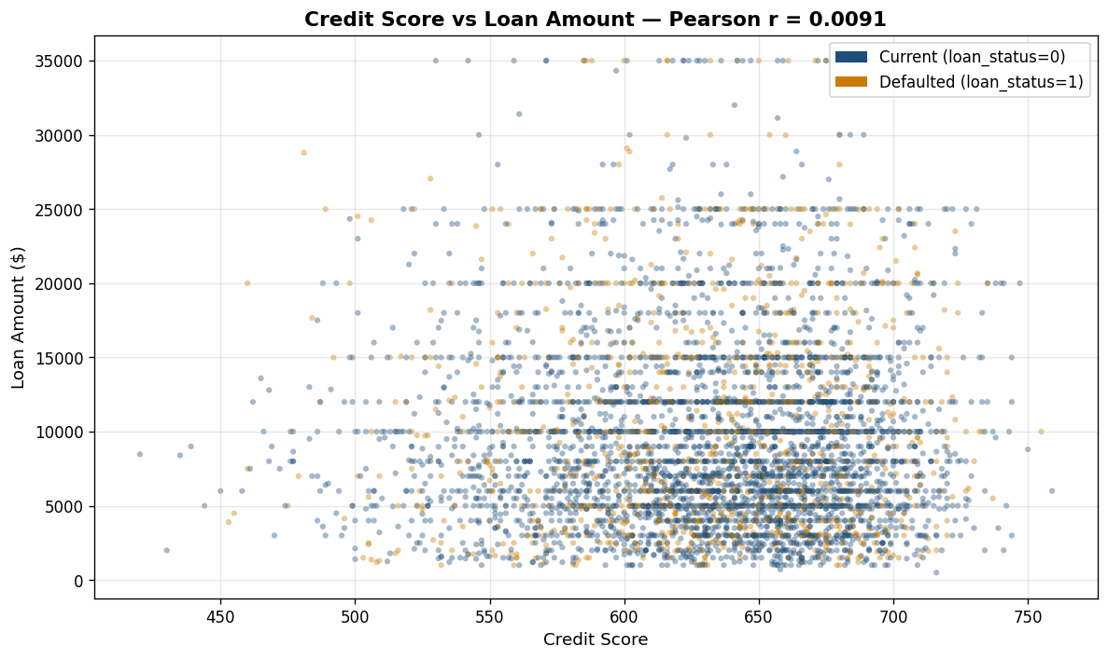
Figure 2 — Credit Score vs Loan Amount (5,000-record sample). Defaulted loans shown in orange, current in blue. The cloud is featureless — there is no pattern relating credit score to loan size.
Conclusion: Loan Sizing is NOT Credit-Aware
Pearson r of 0.009 means borrowers with credit scores of 400 receive loan amounts statistically indistinguishable from borrowers with scores of 800. Combined with the Q3 finding (rates also flat across credit bands), this is the second pricing anomaly we've identified. Together they paint a concerning picture: the bank is using its credit signal to neither price nor size the credit it extends. This warrants an immediate underwriting policy review by the Risk Committee.

Question 8 — Confidence Interval for Portfolio Default Rate

Scenario
The bank samples 500 loans and observes a 4% default rate. We must estimate the true default rate of the full 100,000-loan portfolio.

Method
95% confidence interval for a population proportion using the normal approximation:
CI = p̂ ± z(α/2) × √(p̂(1−p̂)/n)
The normal approximation is valid here because n × p̂ = 500 × 0.04 = 20 ≥ 5 and n × (1−p̂) = 480 ≥ 5.

Calculation
Quantity | Value
Sample size (n) | 500
Sample proportion (p̂) | 0.04 (4%)
z-critical at 95% (two-tailed) | 1.96
Standard error | √(0.04 × 0.96 / 500) = 0.008764
Margin of error | 1.96 × 0.008764 = 0.01718 (±1.72 ppt)
95% Confidence interval (rate) | (2.28%, 5.72%)
Applied to 100,000-loan portfolio | 2,282 to 5,718 expected defaults
Estimate for the Risk Committee
We are 95% confident the true portfolio default rate falls between 2.28% and 5.72%, implying somewhere between roughly 2,300 and 5,700 defaults across the 100,000 loans. The interval is wide (±1.7 ppt) — the upper bound is 2.5× the lower bound. To halve the margin, the sample would need to quadruple to 2,000 loans (since margin shrinks with √n). For board-level stress tests, recommend either (a) a larger sample, or (b) full-population computation from the warehouse.

Question 12 — Primary and Foreign Keys: Loan Application ↔ Credit Bureau History

Conceptual schema
Two tables that need to be joined for risk analysis. Both share borrower_id as a foreign key referencing a master borrowers table.

Table 1 — loan_applications
Column | Role | Notes
application_id | PRIMARY KEY | Surrogate key, unique per application (e.g., APP-000001)
borrower_id | FOREIGN KEY | References borrowers(borrower_id)
application_date | Attribute | When the application was submitted
loan_amnt | Attribute | Requested amount
loan_intent | Attribute | Purpose of the loan
loan_status | Attribute | Approved / Rejected / Pending

Table 2 — credit_bureau_history
Column | Role | Notes
bureau_record_id | PRIMARY KEY | Surrogate key — one borrower has many pulls over time
borrower_id | FOREIGN KEY | References borrowers(borrower_id)
pull_date | Attribute | When the bureau report was retrieved
credit_score | Attribute | FICO/equivalent at pull time
cb_person_cred_hist_length | Attribute | Years of credit history
previous_loan_defaults_on_file | Attribute | Y/N flag

Joining the two — using the credit score available at the time of decision
SQL — Point-in-time join
SELECT
la.application_id,
la.loan_amnt,
cb.credit_score,
cb.previous_loan_defaults_on_file
FROM loan_applications la
JOIN credit_bureau_history cb
ON la.borrower_id = cb.borrower_id
AND cb.pull_date = (
SELECT MAX(pull_date)
FROM credit_bureau_history cb2
WHERE cb2.borrower_id = la.borrower_id
AND cb2.pull_date <= la.application_date
);

Key design decisions
- Why surrogate keys (application_id, bureau_record_id) instead of natural keys? Natural keys (e.g., bureau report numbers) can change format over time; surrogate integer or string keys are stable, compact, and join-efficient.
- Why is borrower_id NOT the primary key in either table? Both tables have many-to-one relationships with the borrower (one borrower applies for multiple loans and has multiple bureau pulls), so borrower_id alone cannot uniquely identify a row.
- Why match on pull_date <= application_date? Risk modeling requires the credit score that was available AT THE TIME the decision was made — not the most recent score. Joining on the latest pull would create look-ahead bias and make the model look more accurate than it actually is in production.

Summary of Findings
Q | Topic | Key Result
1 | 2NF/3NF Normalization | Flat file split into borrowers / credit_history / loans
2 | FULL OUTER JOIN reconciliation | 408 funded loans missing application records — control failure
3 | Interest rate variance | Variance flat across credit bands — pricing not standardized
4 | T-test on income | p < 1e-300; defaulted borrowers earn $26,271 less on average
5 | DAX risk exposure | $108.6M (25.2% of $431.2M portfolio) currently in default
7 | Credit score vs loan amount | r = 0.009 — loan sizing is not credit-aware
8 | Default rate CI | Portfolio default rate: 2.28% to 5.72% (95% CI from n=500)
12 | PK/FK design | Both tables link via borrower_id with point-in-time join logic

Risk Committee Recommendation Themes
- 1. Underwriting policy review is urgent — Q3 and Q7 together show that neither rate nor size is differentiated by credit quality. The pricing model needs immediate audit.
- 2. Reconciliation gaps must be remediated — Q2 found 408 disbursements with no application record. Investigate within the current quarter.
- 3. Income should be a featured signal in default models — Q4 shows income strongly separates defaulters from current borrowers (p < 1e-300).
- 4. Sample sizes for stress tests need review — Q8 shows that 500-loan samples produce imprecise estimates (±1.7 ppt). Increase sample size or use full-population calculations.

